**Project Design Phase**

**Problem – Solution Fit Template**

|  |  |
| --- | --- |
| Date | 27 June 2025 |
| Team ID | LTVIP2025TMID50734 |
| Project Name | Visualizing Housing Market Trends: An Analysis of Sale Prices and Features using Tableau. |
| Maximum Marks | 2 Marks |

**Problem – Solution Fit Template:**

What is the customer struggling with?

Stakeholders in the real estate sector—such as analysts, marketing teams, and executives—face challenges in:

* Identifying which property features influence pricing trends
* Understanding how renovations affect buyer interest and price
* Making strategic decisions without data-backed insights
* Communicating property trends effectively to clients or investors

**Purpose:**

* Solving complex challenges in real estate analysis through actionable, data-driven insights.
* Accelerating adoption by aligning solutions (e.g., Tableau visualizations) with existing behaviors and decision-making patterns.
* Sharpening strategy and communication, ensuring that dashboards, insights, and stories speak directly to stakeholder needs.
* Building trust with users by solving frequent annoyances like unclear trends, pricing confusion, or unstructured data.
* Understanding the current workflows and gaps in analysis, so the final solution is a clear, effective improvement.

**Template:**

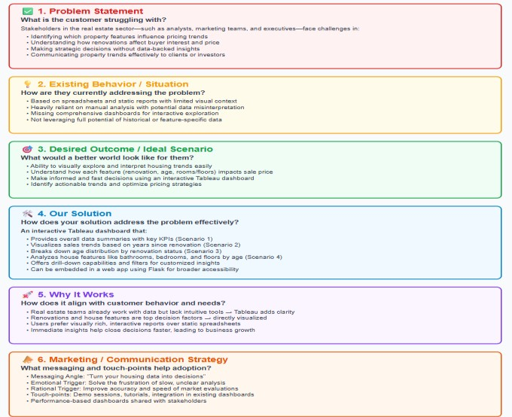

References:

1. Customer development theories by Steve Blank.
2. Lean Startup methodology by Eric Ries.
3. Tableau documentation and real estate BI case studies.
4. Behavioral economics applied to tech adoption (Nir Eyal’s Hooked Model).